Name: Ritika Mohan
Prn: 23070521183
Semester: 5th C (C1)
Aim: Variables, Data Types & ES6+ Features:
Implement variable declarations using var, let, const. Demonstrate ES6 features such as template literals, destructuring, and default parameters. Create a billing calculator using user input and formatted output.
Output:
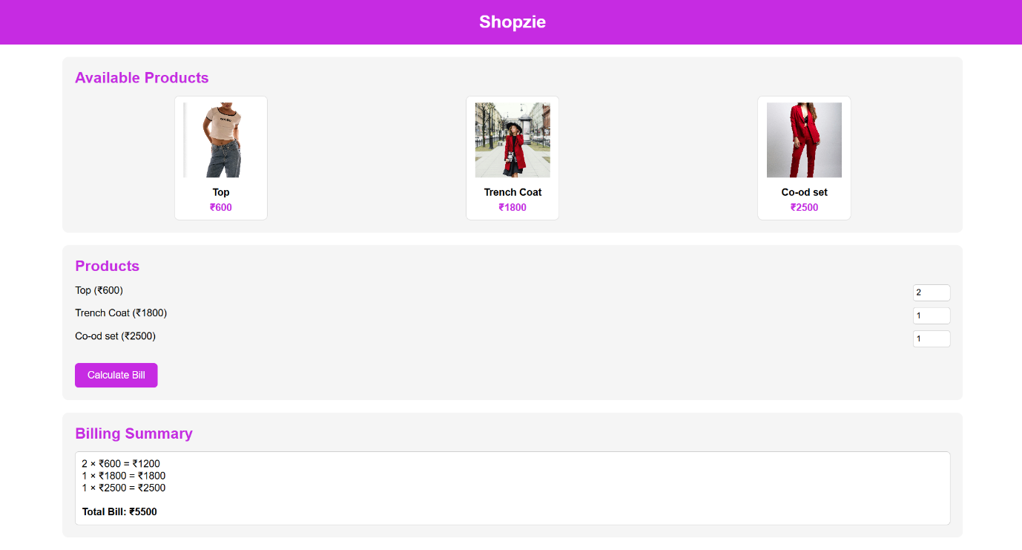
Theory
1. Variable Declarations in JavaScript
JavaScript provides three ways to declare variables:
- var
  - Function-scoped (accessible inside the function where declared).
  - Can be redeclared and updated.
  - Example:
var total = 100;

- let
  - Block-scoped (accessible only inside {} block).
  - Can be updated but not redeclared in the same scope.
  - Example:
let discount = 20;
- const
  - Block-scoped.
  - Cannot be updated or redeclared (used for constants).
  - Example:
const taxRate = 0.18;
2. ES6 Features
- Template Literals
  - Use backticks ` instead of quotes.
  - Allow string interpolation with ${variable}.
  - Example:
console.log(`The total bill is ₹${amount}`);
- Destructuring
  - Extract values from arrays or objects into variables.
  - Example:
const [item1, item2] = ["Apple", "Banana"];
const {price, quantity} = {price: 50, quantity: 3};
- Default Parameters
  - Function parameters with default values.
  - Example:
function calculate(price, qty = 1) {
return price * qty;
}
Conclusion: Developed a webpage for an online shopping website with using HTML,CSS and HTML5 tags and calculated the bill.

